

**University of Koya**

**Faculty of engineering**

**Department of Chemical engineering**

**Control system in distillation towers**

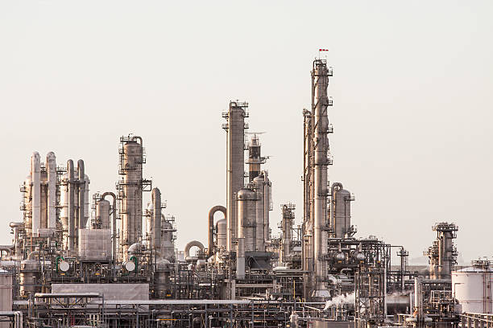

**Prepared by:- Supervisor :-**

**Akam ismail Dr. heaven Emad**

**Twana Dler**

**Mohammed Kazim**

**Ali Hiwa**

Contents

1. Introduction 3

2. Process Dynamics and Modeling: 4

3. Control System Design: 6

4.Advanced Control Strategies and Optimization: 8

5. Case Studies and Industrial Applications: 10

6– Equipment and Parameters :- 11

7. Calculation in controlling systems in distillation Towers: 12

8. Conclusion: 13

References 14

Figure 1 : Pilot Scale 6

Figure 2 : Reflux Temperature in distillation column 8

Figure 3: MPC Model 8

Figure 4: Distillation coulmn at refinery 11

# 1. Introduction

One of the most critical challenges in chemical process control lies not in creating more sophisticated control algorithms but in establishing an effective structural framework. This framework must enable the proper selection of manipulated and measured variables while linking them in a way that ensures efficient control. In practice, achieving this structural balance is fundamental to ensuring stability, efficiency, and reliability in chemical processes, particularly in distillation systems.

In many industrial applications, the theoretically optimal structure—where all available outputs are utilized to compute the control action, connecting all outputs to all inputs—has seen limited adoption. Instead, control system designs have typically favored single-input, single-output (SISO) control loops. A significant amount of research has focused on finding suitable combinations of inputs and outputs to minimize or eliminate detrimental interactions between these loops. This approach reflects the practical challenges of achieving coordination in complex systems with interdependent variables.

The use of variable transformations in process control has demonstrated considerable potential for addressing these challenges. Transformations can be applied to reduce or eliminate interactions between control loops, address nonlinearities in system behavior, or reduce the dimensionality of high-dimensional control problems. Successful applications of variable transformations have been reported across various domains, including pH modeling and control.

In the context of distillation, variable transformations have been a subject of significant interest over the past few decades. Dual-composition control, which involves managing both the product compositions from a two-product distillation column, is a prominent example. This approach aims to mitigate the negative effects of interaction between control loops, ensuring stable and precise separation of components. As process integration advances, similar strategies are expected to be applied to tightly heat-integrated column trains. Additionally, multicomponent distillation systems with substantial side streams represent an area with untapped potential for further exploration. (Waller, 1986)

# 2. Process Dynamics and Modeling:

**Dynamic Behavior of Distillation Columns**

The dynamic behavior of distillation columns is influenced by their inherently complex nature, characterized by multivariable interactions and time-dependent changes. These systems often experience disturbances such as feed composition variations, flow rate fluctuations, and thermal changes, all of which can disrupt steady-state operations. The response of a column to these disturbances depends on several factors, including the design of the column, operating conditions, and the type of control strategies employed

A key aspect of dynamic behavior is the time delay between input changes, such as adjusting the reflux ratio, and the resulting output variations, such as product composition. These delays, coupled with the nonlinear relationships between variables, make distillation towers challenging to control. Stability analysis plays a crucial role in understanding how the system reacts to disturbances and ensuring that the column returns to its desired operating point after deviations. Proper tuning of control systems is essential to minimize oscillations and ensure a quick return to equilibrium.

Understanding the dynamic behavior also involves analyzing the interactions between variables, such as temperature, pressure, and composition, across the column’s height. These variables are interdependent, meaning changes in one can propagate and influence others, creating a complex control environment. Modeling and analyzing these dynamics are vital for designing efficient and responsive control systems that can maintain optimal performance under varying conditions. (Edgar, 2011)

**Mathematical Modeling Techniques**

Mathematical modeling is a powerful tool for understanding, analyzing, and optimizing the behavior of distillation columns. It involves creating representations of the column’s processes through equations that describe the underlying physical and chemical phenomena. Three primary approaches to modeling are widely used: first principles models, empirical models, and hybrid models.

**First principles models** rely on fundamental laws of mass, energy, and momentum conservation to describe the system. These models provide detailed insights into the column’s behavior, including phase equilibrium, heat transfer, and fluid dynamics. While accurate, they often involve complex equations that require extensive computational resources to solve.

**Empirical models** are derived from experimental data rather than theoretical principles. These models are simpler and faster to develop, making them suitable for specific applications where detailed accuracy is not critical. However, their reliability is limited to the range of conditions for which the data was collected.

**Hybrid models** combine the strengths of both first principles and empirical approaches. They integrate theoretical knowledge with data-driven techniques to balance accuracy and computational efficiency. Hybrid models are particularly useful for systems with incomplete theoretical understanding or where real-time computational demands are high.

Each modeling technique has its advantages and limitations, and the choice depends on the specific objectives, system complexity, and available resources. Regardless of the method used, models must be validated against experimental or industrial data to ensure accuracy and reliability (Luyben, 2013)

**Tools and Software for Modeling**

Advancements in computational tools have revolutionized the modeling of distillation columns, enabling engineers to simulate complex dynamics and evaluate control strategies efficiently. Several software platforms are commonly used for this purpose:

* **MATLAB**: Known for its robust mathematical capabilities, MATLAB is widely used for developing and solving dynamic models of distillation systems. Its Simulink extension allows engineers to create block diagrams for simulating control systems and dynamic behavior.
* **COMSOL Multiphysics**: This software excels in multiphysics simulations, making it ideal for cases where thermal, fluid, and structural interactions are critical. While less commonly used for distillation, it provides advanced modeling capabilities for highly specialized applications.

The choice of tools depends on the complexity of the system, the user’s expertise, and the specific requirements of the modeling task. These tools, when used effectively, enhance understanding of distillation dynamics and improve the design of control strategies. (Luyben, 2013)

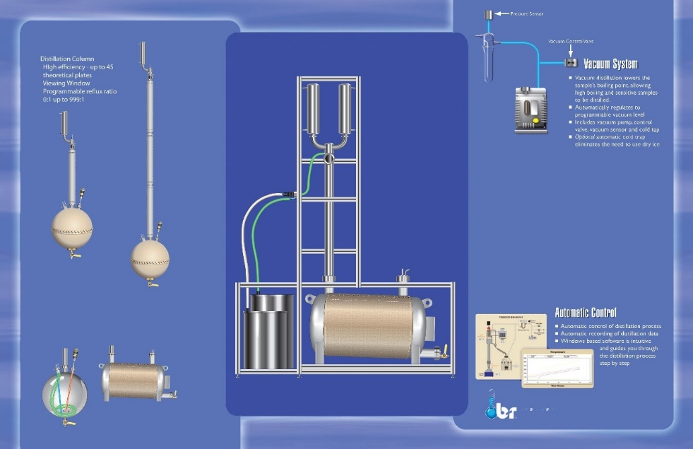

Figure 1 : Pilot Scale

# 3. Control System Design:

**Control Loop Structure**

Control loop structure is the backbone of the control system in a distillation column, defining how process variables are monitored and regulated to ensure stable operation. A typical distillation control system incorporates primary and secondary control loops.

**Primary control loops** focus on essential process parameters such as composition, flow, and pressure. These include:

1. **Product Composition Control**: Ensures the distillate and bottom product meet required purity standards by regulating reflux ratio and boil-up rate.
2. **Reflux Ratio Control**: Maintains the desired separation efficiency by adjusting the flow of condensed liquid back into the column.
3. **Distillate Flow Rate Control**: Regulates the amount of product collected at the top of the column to balance throughput.
4. **Bottom Product Flow Rate Control**: Manages the outflow of residue to maintain inventory and stability at the bottom of the column.

**Secondary control loops** provide support to the primary loops by controlling variables like pressure and temperature:

* **Pressure Control**: Stabilizes the column by regulating the overhead condenser pressure or vent flow.
* **Temperature Control**: Maintains optimal column operation by adjusting heat input or withdrawal.

These interconnected loops ensure the column operates at optimal efficiency and stability, preventing disturbances from cascading through the system. Modern control systems often integrate multivariable control strategies to account for the interdependencies among these loops, improving overall performance. (Coughanowr, 2009)

**Controller Selection and Tuning**

The selection of appropriate controllers and their tuning is critical for achieving precise control in distillation towers. The most common controller type is the **Proportional-Integral-Derivative (PID) controller**, known for its simplicity and effectiveness. PID controllers use three actions to maintain setpoints: proportional action for immediate response, integral action to eliminate steady-state errors, and derivative action to anticipate changes

When tuning a PID controller, parameters such as proportional gain, integral time, and derivative time are adjusted to balance responsiveness and stability. Several methods exist for PID tuning:

* **Ziegler-Nichols Method**: A widely used approach that provides initial tuning parameters based on system oscillations.
* **Trial and Error**: Adjusting parameters incrementally while observing system response, suitable for systems where disturbances are minimal.
* **Software-Assisted Tuning**: Tools like MATLAB and specialized control software can automate the tuning process using advanced algorithms.

In addition to PID controllers, **advanced control strategies** are increasingly being adopted:

* **Model Predictive Control (MPC)**: Utilizes dynamic models to predict future system behavior, optimizing control actions over a prediction horizon.
* **Adaptive Control**: Adjusts control parameters in real time based on process changes, ensuring consistent performance under varying conditions.
* **Fuzzy Logic Control**: Mimics human decision-making by handling imprecise inputs, making it suitable for highly nonlinear processes.

The choice of controller depends on factors such as system complexity, required precision, and the operating environment. Proper tuning enhances system responsiveness while minimizing overshoot and oscillations. (Coughanowr, 2009)

**Control System Implementation**

Implementing a control system in a distillation column involves integrating hardware, software, and instrumentation to ensure smooth operation.

**Hardware Components**:  
Key hardware includes sensors, actuators, and controllers. Sensors such as thermocouples, pressure transducers, and composition analyzers provide real-time data on process variables. Actuators, including control valves and variable-speed pumps, execute the control actions determined by the system. The central controller, often a Distributed Control System (DCS) or Programmable Logic Controller (PLC), coordinates these components to maintain desired operating conditions.

**Software Platforms**:  
Control system software plays a critical role in data acquisition, signal processing, and control algorithm execution. Popular platforms like MATLAB/Simulink and process-specific tools such as Aspen DMCplus enable simulation and implementation of control strategies. Human-Machine Interface (HMI) software provides operators with a graphical interface to monitor and adjust system parameters.

**Control System Integration**:  
Integration ensures seamless communication between hardware and software. Communication protocols like OPC UA and Modbus facilitate real-time data exchange. The system must be designed for reliability, with fail-safe mechanisms and redundancy to handle equipment failures or communication losses. Cybersecurity measures are also critical to protect against unauthorized access or attacks on the control system

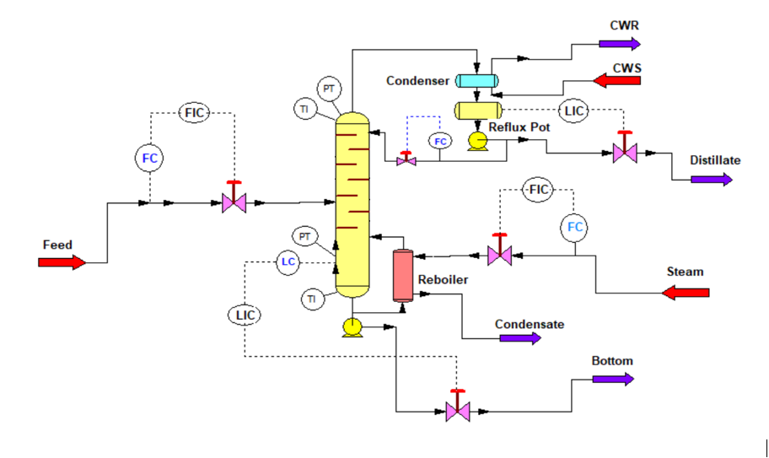Successful implementation involves thorough testing and commissioning to validate system performance under various operating conditions. Continuous monitoring and periodic maintenance are essential to ensure long-term reliability and efficiency. (Coughanowr, 2009)

Figure 2 : Reflux Temperature in distillation column

# 4.Advanced Control Strategies and Optimization:

**Model Predictive Control (MPC)**

Model Predictive Control (MPC) is an advanced control strategy that has gained significant popularity in the optimization of distillation processes. MPC differs from traditional control methods in that it predicts future system behavior using a mathematical model, making it highly effective for systems with complex dynamics like distillation columns. The primary advantage of MPC is its ability to optimize the control inputs over a finite prediction horizon, taking into account constraints on both inputs and outputs

MPC operates by using a dynamic model of the system to predict future outputs based on the current state and inputs. The controller then solves an optimization problem to determine the best control actions that minimize a predefined cost function, which typically includes terms for setpoint tracking, energy usage, and process stability. Once the optimal control actions are calculated, only the first step is implemented, and the process is repeated at the next time step, allowing the controller to continuously adjust to changes in the system and disturbances

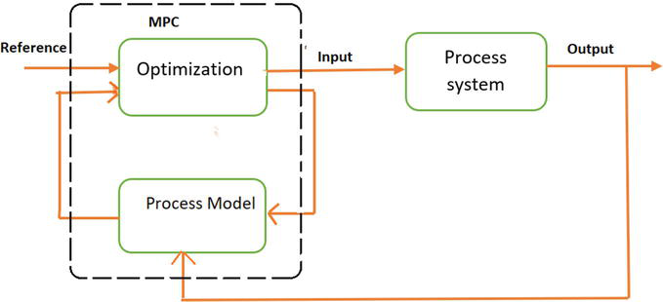

Figure 3: MPC Model

One of the main benefits of MPC is its ability to handle multivariable systems with constraints, which are common in distillation columns. By simultaneously considering interactions between multiple variables—such as composition, flow rates, and temperature—MPC can make more informed control decisions that improve overall system performance. This method is particularly effective in maintaining product quality and process stability, even when the system experiences disturbances or operates under changing conditions.

MPC also enables the integration of advanced models, such as nonlinear models, and can handle large-scale systems that traditional control methods might struggle with. However, it requires accurate models and significant computational resources, making its implementation more complex and expensive compared to simpler methods like PID control. (Emerson, 2022)

**Real-Time Optimization (RTO)**

Real-Time Optimization (RTO) is an advanced optimization technique used to improve the performance of distillation columns by continuously adjusting operational variables to optimize a specific objective, such as maximizing throughput or minimizing energy consumption. RTO uses real-time process data, such as flow rates, temperatures, and compositions, to adjust the operating setpoints of the column in real-time.

The key advantage of RTO is its ability to continuously adapt to changing process conditions, optimizing performance while respecting operational constraints. For instance, RTO can dynamically adjust parameters like reflux ratio and boil-up rate to maintain the optimal separation efficiency despite variations in feed composition or disturbances. This capability is crucial in ensuring that the distillation column operates at peak efficiency, reducing energy consumption and operational costs.

RTO relies on accurate process models to predict the future behavior of the system and identify the optimal operating conditions. These models are typically based on first-principles or empirical data, and they allow the RTO algorithm to calculate the best control actions in real-time. Unlike traditional optimization methods that work on steady-state conditions, RTO continually updates its optimization strategy based on real-time data, making it ideal for processes with frequent changes.

The implementation of RTO is usually coupled with a supervisory control layer that adjusts the setpoints in a way that ensures system stability and efficiency. Despite its advantages, RTO requires robust modeling, real-time data acquisition, and high computational power, which can increase the complexity of its implementation (Emerson, 2022)

**Multivariable Control**

Multivariable control is an essential strategy in the control of complex systems like distillation columns, where multiple variables interact with each other and affect system behavior. Traditional single-loop control methods, such as PID, may struggle to maintain optimal performance in such systems due to the interdependencies between variables like temperature, pressure, composition, and flow rates. Multivariable control addresses this issue by simultaneously controlling several variables in the system, allowing for more coordinated and effective regulation of the distillation process.

One of the key techniques in multivariable control is **decentralized control**, where separate control loops are designed for each variable. These loops operate independently but are coordinated to achieve the overall system objectives. Decentralized control is often used when it is difficult to implement a fully integrated control system. However, this approach can be less effective in handling complex interactions between variables and may lead to performance degradation in certain scenarios.

In contrast, **centralized control** involves designing a single controller that simultaneously manages multiple control loops. This approach offers a more integrated solution, taking into account the interactions between variables and ensuring a more stable and efficient operation. **Decoupling** is a technique used in centralized multivariable control to minimize the interaction between control loops. By modifying the system’s dynamics, decoupling allows the controller to treat each loop as if it were independent, which simplifies the control strategy and improves performance ( (Emerson, 2022)

Another technique within multivariable control is **model-based control**, which uses mathematical models to predict the future behavior of the system. This approach, often combined with Model Predictive Control (MPC), helps improve control by accounting for the interactions between variables and predicting the optimal control actions. For instance, in a distillation column, a model-based multivariable controller can optimize both reflux ratio and distillate flow rate simultaneously, taking into account their mutual influence on the product composition.

The main challenge in multivariable control is the complexity of tuning and maintaining stability when managing multiple variables. Advanced algorithms like **state-space models**, **Kalman filtering**, and **neural networks** can be used to improve the accuracy of multivariable models and control strategies. These methods enhance the controller's ability to respond to disturbances and process variations. Despite its advantages, implementing multivariable control can be resource-intensive and requires significant computational power to handle the complex models and calculations involved (Emerson, 2022)

# 5. Case Studies and Industrial Applications:

**Case Study 1: Petroleum Refinery Distillation Column**

In petroleum refineries, distillation columns play a crucial role in separating crude oil into its various components, such as gasoline, diesel, kerosene, and other by-products. One notable case involves optimizing the operation of a distillation column to improve energy efficiency and product yield. The control system utilized Model Predictive Control (MPC) to manage multiple variables simultaneously, such as temperature, pressure, and reflux ratio. This advanced control strategy enabled real-time adjustments to operating conditions, maximizing the separation efficiency while minimizing energy consumption. The integration of real-time data and predictive models allowed the refinery to quickly respond to changes in feed composition, resulting in improved product quality and reduced operational costs. By incorporating advanced optimization techniques like Real-Time Optimization (RTO), the refinery was able to achieve optimal operating conditions even during fluctuations in raw material quality, ensuring consistent output and reducing wastet (Mathey, 2020)

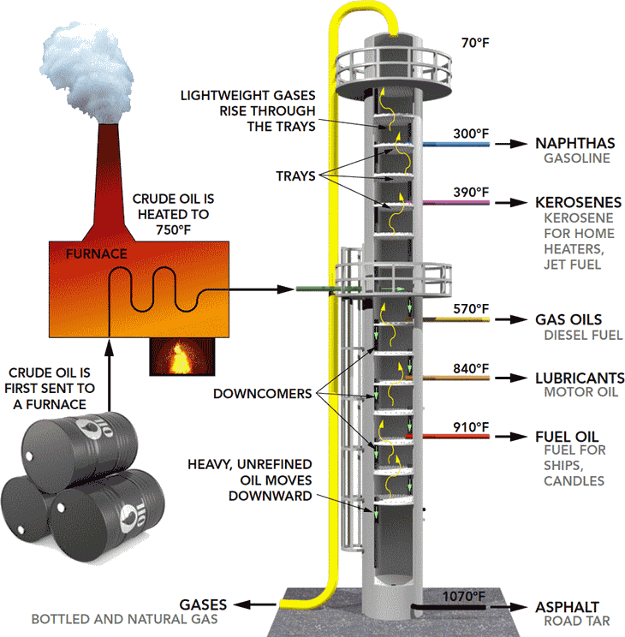

Figure 4: Distillation coulmn at refinery

**Case Study 2: Chemical Plant Distillation Column**

A chemical plant specializing in the production of specialty chemicals faced challenges related to maintaining consistent product quality and minimizing energy usage in its distillation columns. To address these issues, a combination of advanced control strategies was implemented, including MPC and multivariable control. These strategies allowed the plant to better control key parameters such as temperature profiles, flow rates, and column pressure. The control system was also integrated with real-time optimization algorithms to continuously adjust operating conditions based on fluctuating feed compositions and external disturbances. By implementing these advanced strategies, the plant was able to significantly reduce energy consumption and improve product purity, leading to both cost savings and enhanced product quality. Furthermore, the system’s ability to handle complex interactions between multiple variables ensured stable and efficient column operation ( (Taylor, 2017)

**Industrial Challenges and Solutions**

In distillation column control, common challenges include fluctuating feed composition, energy efficiency, and maintaining stable product quality. Solutions often involve integrating advanced control systems like MPC and RTO, which allow for real-time adjustments and optimization . (Taylor, 2017)

# 6– Equipment and Parameters :-

Control systems in distillation towers rely on various specialized equipment to monitor and regulate critical parameters, ensuring efficient and stable operations.

**1. Temperature Sensors:**  
Temperature sensors are vital for measuring the temperature at various points in the column, such as trays or packing levels. These measurements indicate the thermal profile of the column, which is crucial for maintaining the desired separation efficiency. Accurate temperature control helps ensure that each component vaporizes and condenses at the correct stages, achieving optimal product purity.

**2. Pressure Transmitters:**  
Pressure transmitters monitor the pressure inside the column, which directly affects boiling points and phase equilibrium. Maintaining consistent pressure is essential for stable operation, as fluctuations can lead to inefficiencies or disruptions in the separation process.

**3. Composition Analyzers:**  
These devices measure the concentration of components in the distillate or bottoms product. Indicators like purity levels are critical for quality assurance, and real-time composition analysis allows operators to adjust variables like reflux ratio or boil-up rate to meet specifications.

**4. Flow Meters:**  
Flow meters measure the rates of liquid and vapor flows within the system, such as feed rate, reflux flow, and product withdrawal. These indicators help balance the material throughout the column, preventing flooding or weeping and ensuring consistent performance.

**5. Control Valves and Actuators:**  
Control valves regulate the flow of fluids, while actuators adjust these valves based on signals from the control system. For example, a valve might control steam flow to the reboiler to adjust heat input, directly influencing the separation process.

By integrating these instruments into advanced control strategies, operators can continuously monitor key parameters and respond dynamically to disturbances, optimizing both product quality and energy effi (Ponton, 2007)

# 7. Calculation in controlling systems in distillation Towers:

**Mathematical Question**

**Given a distillation column with the following transfer function for temperature control:**

***G(s)*= 5 / (s+1)(s+2)**

Design a PID controller with the following tuning parameters: Kp =2 =, T*i* =1, and T*d* = 0.5. Write the closed-loop transfer function of the system.

**Solution**

**Step 1: PID Controller Transfer Function**

The general transfer function of a PID controller is:

***C(s)* = K*p* / (1 + 1 / T*is* + T*ds*)**

Substitute K**p** = 2 , T***i*** =1, and T***d*** = 0.5:

***C(s)* = 2 (1 + 1 / s + 0.5s) = 2 + (2 / s + s)**

**Step 2: Open-Loop Transfer Function**

The open-loop transfer function of the system is:

***L(s)* = *C(s)* * *G(s)* = (2 + 2 / s + s) * 5 / (s + 1) (s + 2)**

Simplify:

***L(s)* =[10 / (s+1) (s+2) ] + [ 10 / s (s+1) (s+2) ] + [5s / (s+1) (s+2)]**

**Step 3: Closed-Loop Transfer Function**

The closed-loop transfer function is given by:

***T(s)* = *L(s)* / 1 + *L(s)​***

Substitute L(s) into the equation and simplify to obtain the closed-loop transfer function.

***T(s)* = [ (10 /(s + 1)(s + 2)) + (10 /s(s + 1)(s + 2)) + (5s /(s + 1)(s + 2)) ] /**

**[ 1 + (10 /(s + 1)(s + 2)) + (10 /s(s + 1)(s + 2)) + (5s /(s + 1)(s + 2))]**

This calculation illustrates how mathematical tools are applied to design and analyze control systems in distillation processes. Accurate modeling and tuning ensure that the system operates efficiently, maintaining stable and optimized separation.

# 8. Conclusion:

In conclusion, distillation column control is vital for optimizing product quality, energy efficiency, and operational stability. Advanced control strategies such as Model Predictive Control (MPC), Real-Time Optimization (RTO), and multivariable control offer significant improvements over traditional methods. Integrating emerging technologies like AI, digital twins, and cyber-physical systems will continue to enhance performance, enabling more adaptive and efficient processes.

Future research should focus on integrating AI and machine learning with existing control strategies to further improve process adaptability and predictive capabilities, as well as enhancing sensor technologies for greater precision in real-time control.

# References

Coughanowr, D. R., 2009. Controller and section and tuning . In: 3rd, ed. *Process Systems analysis and control.* s.l.:Donald R. Coughanowr.

Edgar, S. .., 2011. Dynamic behavior of distillation coulmn. In: 3rd, ed. *Process Dynamic and control.* s.l.:Seborg .D.E Edgar, pp. 68-75.

Emerson, 2022. *emerson.* [Online]   
Available at: https://www.emerson.com/en-us/global

Luyben, W. l., 2013. Mathmatical models of chemical enginering systems . In: 2nd, ed. *Process Modeling , Simulation and Control for chemical engineers.* 2nd ed. s.l.:Luyben, pp. 17-38.

Majicesovki, J., 2002. *Research.* [Online]   
Available at: https://www.researchgate.net/publication/244972046_Predictive_control_with_constraints_JM_Maciejowski_Pearson_Education_Limited_Prentice_Hall_London_2002_pp_IX331_price_3599_ISBN_0-201-39823-0

Mathey, J., 2020. *Mathey.com.* [Online]   
Available at: https://technology.matthey.com/content/journals/jmtr/browse

Ponton, J., 2007. *homepages.* [Online]   
Available at: https://www.homepages.ed.ac.uk/jwp/control06/controlcourse/restricted/course/fourth/course/module3-1.html

Taylor, M., 2017. Chenical pant in distillation coulmn. In: 2nd, ed. *Industrial Process Control Systems.* s.l.:Taylor,M, p. 6.

Waller, K., 1986. *Science direct.* [Online]   
Available at: https://www.sciencedirect.com/science/article/pii/S1474667017593921?ref=cra_js_challenge&fr=RR-1